**Introduction:** We developed a Eid festival scenario based graphics project using opengl API. Our scenario is actually a normal Eid festival scene where we develop multiple Object according to project proposal. Here, in project we use different types of library function such as glut (GLUT is the OpenGL Utility Toolkit, a window system independent toolkit for writing OpenGL programs. It implements a simple windowing application programming interface (API) for OpenGL. GLUT makes it considerably easier to learn about and explore OpenGL Programming).We considerably use c programming language in project. Different type of library function is being added to make interactive project. This is a set of functions to create texture of an object from a base image, map coordinates between screens and object space, and draw quadric surfaces. Project will be well organized using proper function and well documented.

**Problem Statement:** In this project, we needed to create a real life scenario of a Eid festival using opengl API. We needed to create objects that’s a Eid festival normally have. And we needed to give that scenario using animation and sound. We needed to build amosque, trees, tent, roads, mary go round, sky, moon, cloud small mountain etc. After that we need to add those objects together and create a complete scenario. That’s not all. After that we needed to create animation like morning, day, night mode and moving and rotating object like mary goround and train etc. Lastly adding sound will complete that project.

**Objective of the project:** This project based on scenario based project. We tried to create an animation based Eid festival scenario. One day mode we tried to create rising sun with moving clouds. In the background we tried to add some trees. We tried to add some Eid festival based carnival. And there were trees surrounding those areas. In the front there we tried to put rail tracks with a moving train. In sky we tried to add clouds which are moving in different direction. We added a car along a road. The car is a moving along that road. We also tried to add some lamps beside that road. In day mode the sun color will be changed from reddish to yellow. And sun position will be adjusted to the time. Sky and river color will be changed to deep. Lighting effect will be stronger in day mode. In night mode all the lights will be turned on. The train will turn on its light. Lamp post’s side the road will also be turn on. The sun will replaced with moon and there we tried to put some stars in the sky. We also changed the cloud color. And other village object, we tried to make it darker. We also tried to add raining mode in this project. If certain event clicked rain will be started and certain event click will stop the rain. And this whole morning, day, and night mode we tried to make it automated. After certain times the mode will change automatically.

**Methodology & System Implementation:** In this project, we used some tools Tools that are used in this projects:

1. Opengl
2. Code Blocks
3. . Sound API

**Significant of the project:** This project can be used as an education application or tourist application. We can describe how a Eid festival really looks like in these types of projects. This project application can be shown to children to let them know more about Eid festival in small towns with animated visual effects. This will really grow their interest in visual learning.

**Conclusion:** In this project, we are trying to build a Eid festival scenario based project. In this project we use OPENGL API. For language we use c language. In this project we create day night effect, home, train, etc. In this project the clouds, rain and train are moving object which can move and stop by keyboard interaction. In this project every object is indicated by fixed function and fixed interactive function. For if we want to change or update the object we can change it easily. In this project we can also have some limitation which can be done in future. In this there is a problem in rain which can be done in future. Also we can add some feature in future in this project.

**Screenshot:**

Day:

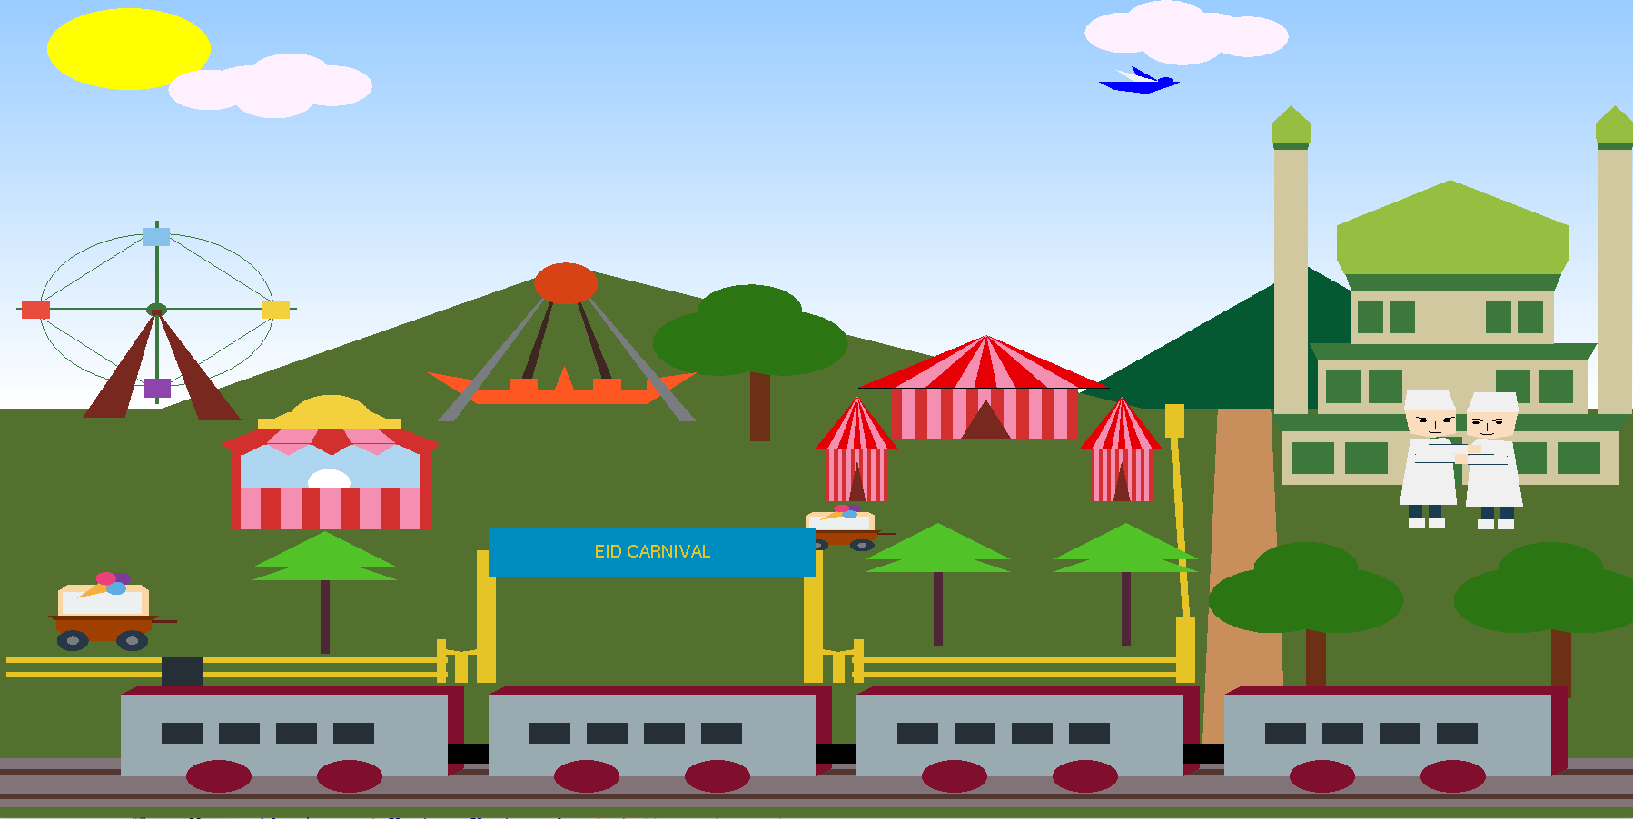

Night:

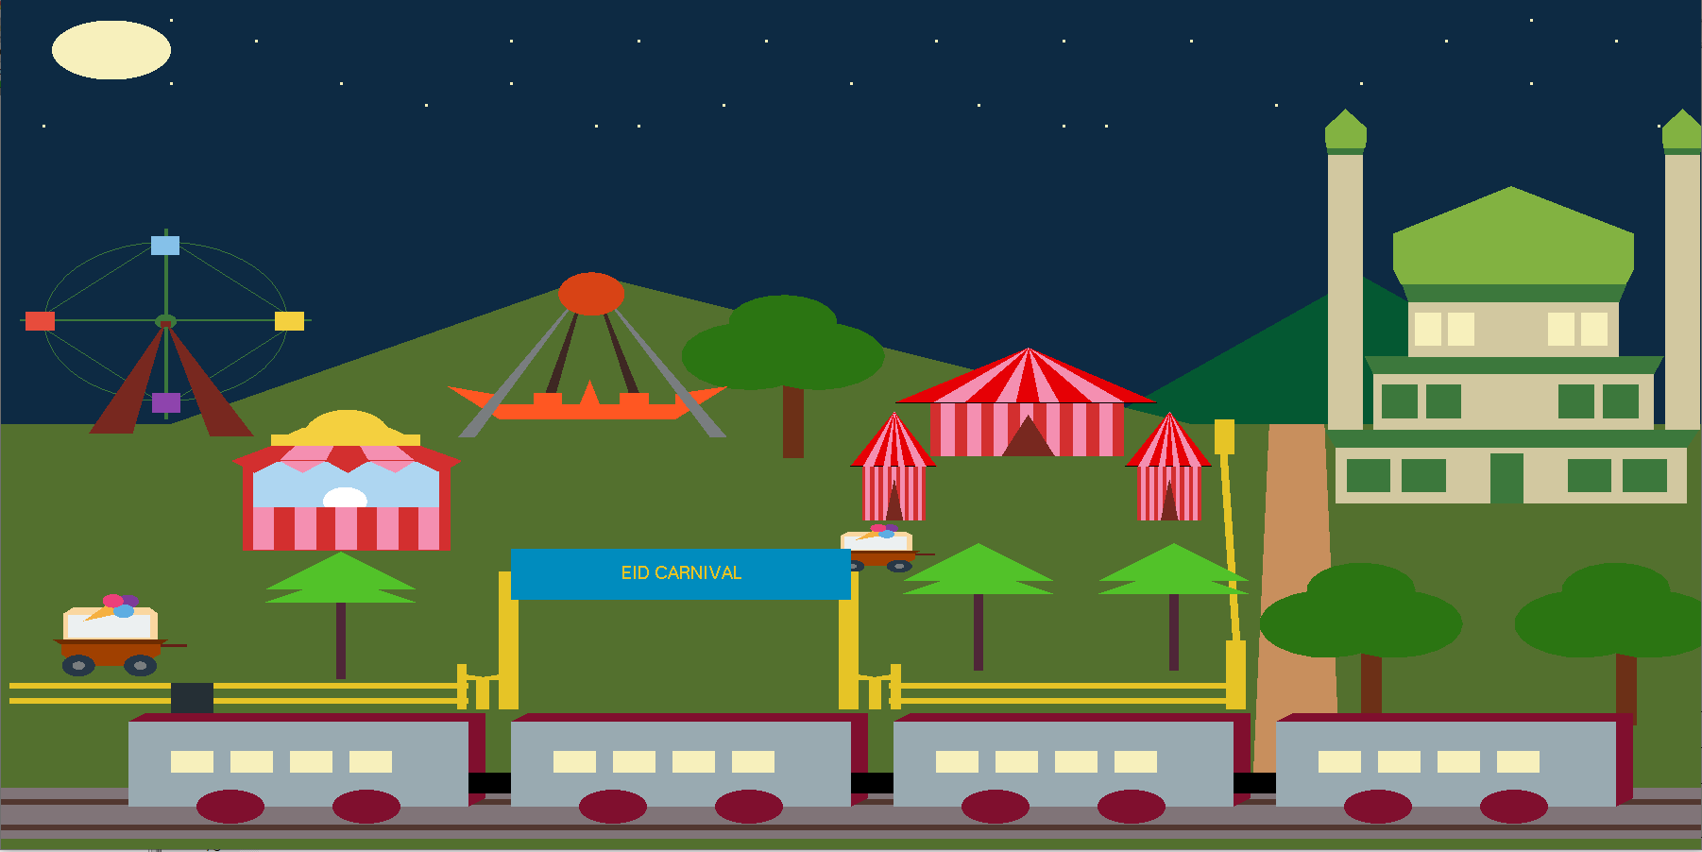

Rain:

